System Hardening Project
Allan Wheelock
University of Advancing Technology

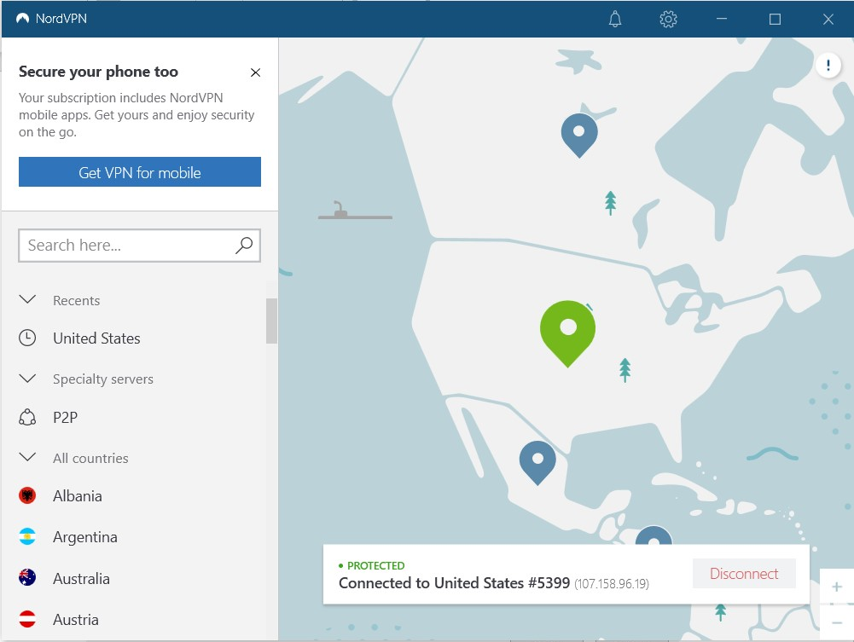
I installed NordVPN on all my devices that connect to the internet. Since I live in a student living apartment complex my home network is also a public network. So, it’s very important for me to always be connected to a VPN since everyone in my building is on the same network.
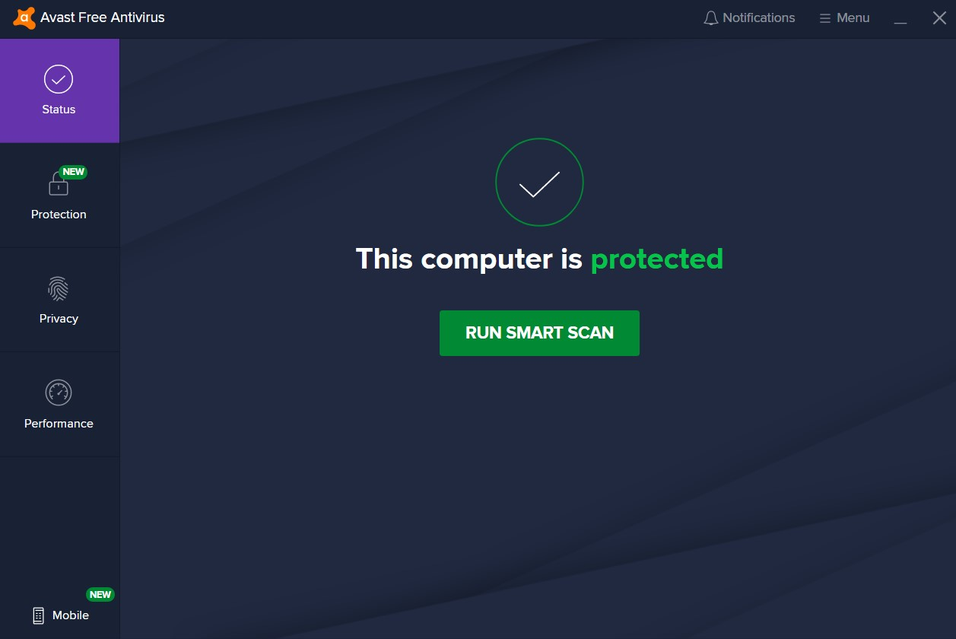
I installed Avast Free Antivirus on my computer to protect it from threats. This service provides scans of my machine in order to monitor it for malware and viruses. It also has a plugin for my web browser that scans websites before I click on them to make sure they’re not malicious websites.
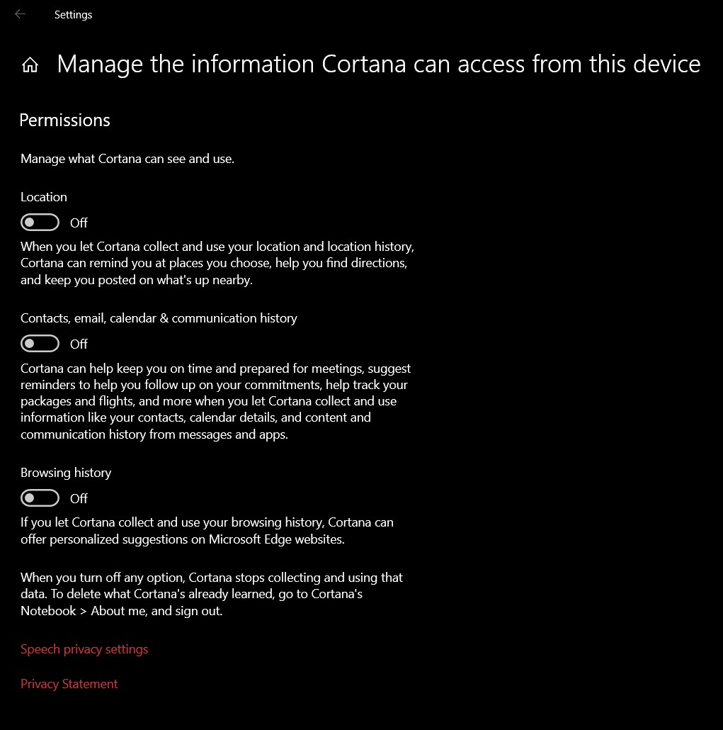
I went through my Cortana settings for this part and turned off all the permissions I could with Cortana in order to completely disable it. I also went and cleared all the data that was being stored from Cortana in the cloud from this device. I don’t think I’ve ever used it before, but I don’t like the idea of my microphone just being on all the time.

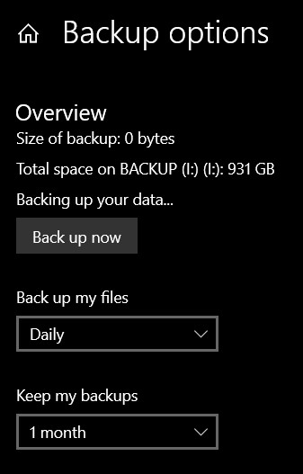
Here I set up my computer to do a full backup daily. I have a dock I plug my laptop into whenever I’m at home that has a 1 TB external hard drive connected to it. I dedicated this drive to be a backup drive so all my data from my laptop will be stored here in case I need to revert to a backup.

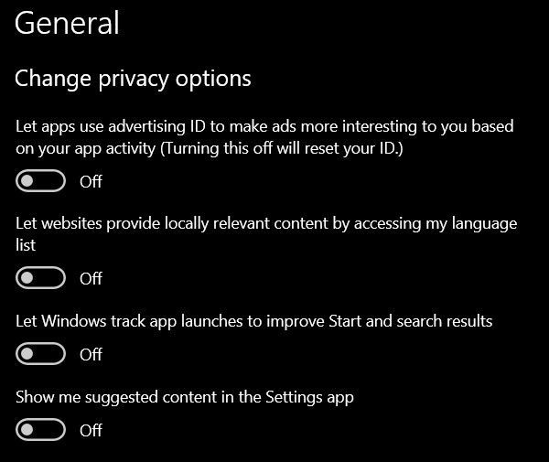
I went and changed all my privacy settings in this area of the settings menu. This way my laptop isn’t tracking anything that I’m doing without my permission. By turning all these options off it makes my laptop more secure.

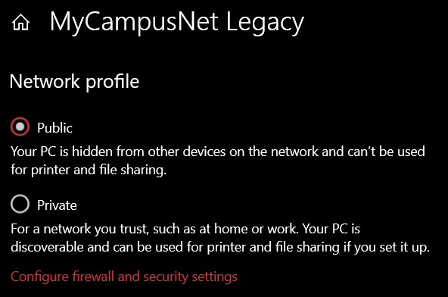
As well as using a VPN, I have my laptop set to treat my home network as a public network. As I stated before, my apartment complex is a “student living” apartment complex so they have one network that every resident uses. By having this setting enabled it keeps my laptop hidden from being seen from other machined on the network. Doing this and using a VPN should help me stay safe and hidden from everyone that is using this network.

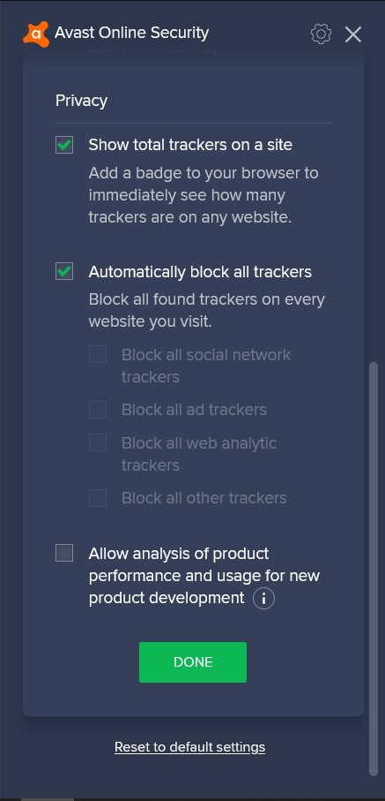
My antivirus software also came with a plugin for Firefox that keeps websites and ads from tracking me online. This keeps random companies and websites from collecting my data when I access their websites.
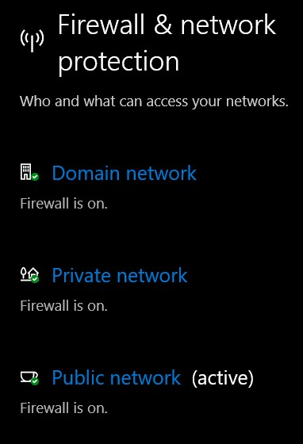
This screenshot shows that my Windows Firewall is setup to always be on. This makes sure that no matter what kind of connection I have to the internet, I’ll have my firewall up and protecting my laptop. This is important because even on home networks or secure networks I want to have a firewall on just in case that network became compromised.

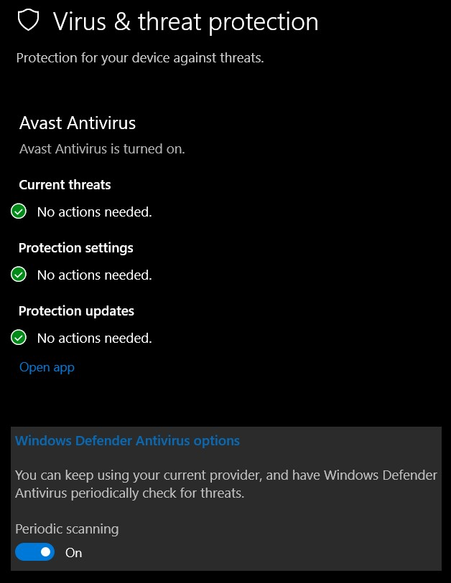
Here I have set my laptop to run my antivirus along with Windows Defender. My family has used Avast Antivirus with all our computers in the past, so I trust it quite a bit. But running it along with Windows Defender just ensure that my laptop is even more secure.

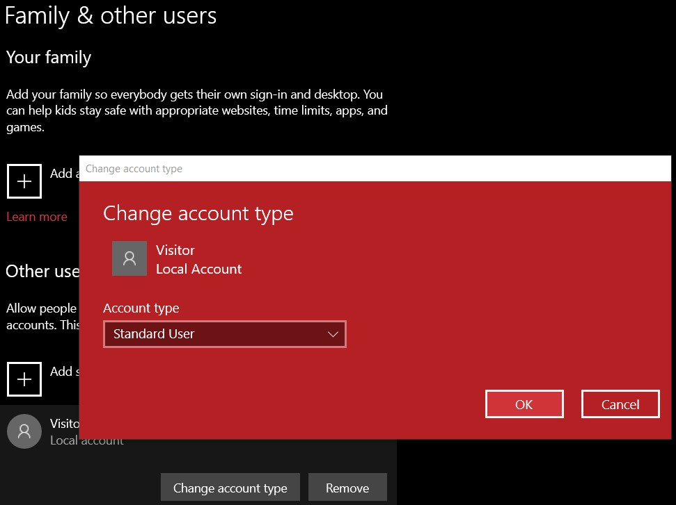
I have created a local user account that has guest restrictions and cannot operate as an administrator. This is important because if malware is installed on my machine, it can’t make any damaging changes to system files. By using a standard account, attackers that get in while this account is in use can only gain access to this account’s files, which keeps my administrator account’s files protected.
References
Fox, A., 2020. Why You Shouldn't Use An Admin Account As Your Main Account - Make Tech Easier. [online] Make Tech Easier. Available at: <https://www.maketecheasier.com/why-you-shouldnt-use-admin-account/> [Accessed 28 September 2020].
https://synchronic.uat.edu/courses/3480/assignments/125972?module_item_id=311520

